**Model Development Phase Template**

|  |  |
| --- | --- |
| Date | 20 November 2025 |
| Team ID | 740018 |
| Project Title | Deepfruitveg:Automated Fruit And Vegetables Identification |
| Maximum Marks | 10 Marks |

**Initial Model Training Code, Model Validation and Evaluation Report**

The initial model training code will be showcased in the future through a screenshot. The model validation and evaluation report will include a summary and training and validation performance metrics for multiple models, presented through respective screenshots.

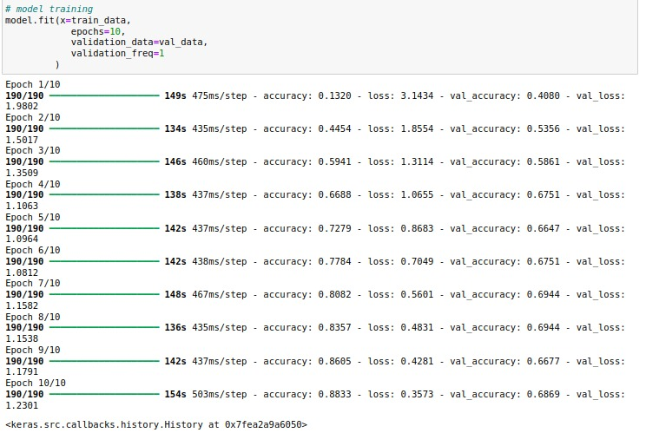

**Initial Model Training Code (5 marks):**

**Model Validation and Evaluation Report (5 marks):**

|  |  |  |
| --- | --- | --- |
| **Model** | **Summary** | **Training and Validation Performance Metrics** |
| Model 1 | Screenshot of the neural network summary | Screenshot of the training and validation performance metrics (output of the model.fit()). |
| Model 2 | Screenshot of the neural network summary | Screenshot of the training and validation performance metrics (output of the model.fit()). |
| … | … | … |